|  |  |  |  |
| --- | --- | --- | --- |
| **TABLE OF CONTENTS** | | | |
|  |  | ***Title*** | ***Page No.*** |
|  | **TABLE OF CONTENTS** | | 04 |
| **1** | **INTRODUCTION** | |  |
|  | 1.1 Project Idea | | 12 |
|  | 1.2 | Overview | 13 |
|  | 1.3 | Modules | 14 |
| **2** | **SOFTWARE REQUIREMENT SPECIFICATION** | | |
|  | 2.1 Introduction | | 16 |
|  | 2.2 Functional Requirements | | 17 |
|  | 2.3 Non Functional Requirements | | 19 |
|  | 2.4 | Hardware Requirements | 22 |
|  | 2. 5 Software Requirements | | 22 |
| **3** | **ANALYSIS AND DESIGN PHASE** | |  |
|  | 3.1 Introduction | | 25 |
|  | 3.2 Class Diagram | | 25 |
|  | 3.3 | Object Diagram | 26 |
|  | 3.4 | Activity Diagram | 27 |
|  | 3.5 | Sequence Diagram | 28 |
|  | 3.6Collaboration Diagram | | 29 |
|  | 3.7State chart Diagram | | 30 |
| 3.8 Component Diagram | | | 31 |
|  | 3.9Deployment Diagram | | 31 |
|  | 3.10 Data Design | | 32 |
|  | 3.11 Conclusion | | 35 |

|  |  |
| --- | --- |
| **4 SYSTEM LOW LEVEL DESIGN** |  |
| 4.1 Modules of the project | 37 |
| 4.2 Objectives | 37 |
| 4.3 Project overview | 38 |
| **5 IMPLEMENTATION** |  |
| 5.1 Same Code | 41 |
| 5.2 Screen Captures | 52 |
| 5.3 Firebase Analytics | 59 |
| **6 TESTING** |  |
| 6.1 Software Testing | 63 |
| 6.2 Black Box Testing | 63 |
| 6.3White Box Testing | 63 |
| 6.4 Performance Testing | 63 |
| 6.5Load Testing | 63 |
| 6.6Manual Testing | 63 |
| 6.7Firebase Test Lab | 67 |
| **7 RESULTS AND CHALLENGES** |  |
| 7.1 Results | 70 |
| 7.2Challenges | 70 |
| **8 CONCLUSION AND FUTURE WORK** |  |
| 8.1 Conclusion | 72 |
| 8.2Scope for future work | 72 |
| 8.3Limitations | 72 |
| **BIBILOGRAPHY** | 73 |

## LIST OF FIGURES

|  |  |  |
| --- | --- | --- |
| **FIGURE NO** | **TITLE** | **PAGENO** |
| 2.1 | Use Case Diagram | 21 |
| 3.2 | Class Diagram | 25 |
| 3.3 | Object Diagram | 26 |
| 3.4 | Activity Diagram | 27 |
| 3.5 | Sequence diagram | 28 |
| 3.6 | Collaboration diagram | 29 |
| 3.7 | State Chart diagram | 30 |
| 3.8 | Component diagram | 30 |
| 3.9 | Deployment diagram | 31 |
| 5.2.1 | User login screen | 52 |
| 5.2.2 | Forgot password page | 52 |
| 5.2.3 | User sign up page | 53 |
| 5.2.4 | User home screen | 53 |
| 5.2.5 | Service page | 54 |
| 5.2.6 | Booking page | 54 |
| 5.2.7 | All bookings page | 55 |
| 5.2.8 | Referral page | 55 |
| 5.2.9 | User profile page | 56 |
| 5.2.10 | Service provider login page | 56 |
| 5.2.11 | Service provider signup page | 57 |
| 5.2.12 | Service provider bookings | 57 |
| 5.2.13 | Reference page | 58 |
| 5.2.14 | Service provider profile page | 58 |
| 5.3.1 | Firebase Authentication | 59 |
| 5.3.2 | Password reset mail template | 59 |
| 5.3.3 | Firebase Database | 60 |
| 5.3.4 | Active sessions | 60 |
| 5.3.5 | User engagement | 61 |

|  |  |  |
| --- | --- | --- |
| 6.1 | Test case for empty login | 64 |
| 6.2 | Test case for wrong login | 65 |
| 6.3 | Test case for signup fail | 66 |
| 6.4 | Test case for user signup fail | 67 |
| 6.7 | Firebase test lab clusters | 68 |

**LIST OF TABLES**

|  |  |  |
| --- | --- | --- |
| Table 3.10.1 | SQLite Database | 32 |
| Table 3.10.2 | List of tables in database | 32 |
| Table 3.10.3 | Admin table | 32 |
| Table 3.10.4 | Users table | 33 |
| Table 3.10.5 | Service providers table | 33 |
| Table 3.10.6 | Bookings table | 34 |
| Table 3.10.7 | Services table | 34 |
| Table 6:1 | Test case for empty login fields | 64 |
| Table 6:2 | Test case for wrong login fields | 64 |
| Table 6:3 | Test case for signup fail | 65 |
| Table 6:4 | Test case for User signup fail | 67 |

**ACRONYMS & ABBREVIATIONS**

|  |  |
| --- | --- |
| * **HTML:** | Hyper Text Markup Language. |
| * **XML:** | Extensible Markup Language. |
| * **IDE:** | Integrated Development Environment |
| * **PHP:** | Hyper Text Preprocessor |
| * **RDBMS:** | Relational Database Management System. |
| * **GUI:** | Graphical User Interface |
| * **HTTP:** | Hyper Text Transfer Protocol |
| * **API:** | Application Programming Interface |
| * **E-R:** | Entity-Relationship |
| * **UML:** | Unified Modeling Language |
| * **OOAD:** | Object-Oriented Analysis & Design. |

**INTERNSHIP SUMMARY**

**Location:**Hyderabad

**Center:** “Name of the organization”

**Duration:**

**Date of start:**

**Date of submission:**

**Title of project:**

**Team Members:**

xxxxxx(151FA0xxxx) xxxxxx(151FA0xxxx) **Name of the guide:**

**Name of Faculty guide:** VFSTR University. **Project Area: Network Intrusion detection**

**Abstract:**

* In this paper author is describing concept to control or automate green traffic signal allotment time based on congestion available at road side using Canny Edge Detection Algorithm. To implement this technique we are uploading current traffic image to the application and application will extract edges from images and if there is more traffic then there will be more number of edges with white colour and if uploaded image contains less traffic then it will have less number of white colour edges. Empty edges will have black colour with value 0. By counting number of non-zeroes white pixels we will have complete idea of available traffic and based on that we will allocate time to green signal. If less traffic is there then green signal time will be less otherwise green signal allocation time will be more.

**Signature of Student Signature of Faculty Guide**

**Date: Date:**

# PROFILE OF THE COMPANY

**About ECIL**

**Electronics Corporation of India Limited (ECIL)** is a Government of India Enterprise under the Department of Atomic Energy, established on April 11, 1967 by A. S. Rao at Hyderabad, to create a strong indigenous base in electronics. ECIL is a multi-product, multi- disciplinaryorganization with focus on indigenous Nuclear energy, space and Defense sectors. ECIL also has a strong presence in indigenous Electronic Security, Communications, Networking and e-governance domains. ECIL has committed partnerships with nuclear energy establishments of India, particularly Bhabha Atomic Research Center (BARC), Nuclear Power Corporation of India Limited (NPCIL) and Indira Gandhi Centre for Atomic Research (IGCAR). ECIL also actively supports other strategic sectors such as indigenous Defense (Defense Research and Development Organization(DRDO)), Space (Department of Space (India))Civil Aviation, Information and Broadcasting, Telecommunications, Insurance, Banking, Police and Para-military Forces, Oil and Gas, Power, Space Education, Health, Agriculture, Steel and Coal. ECIL is credited with producing the first indigenous digital computers, TDC 312 and TDC 316, solid state TV, control and instrumentation for nuclear power plants and first earth station antenna of India.

**Company address:**

A.S. Rao Nagar, ECIL, Hyderabad

***CHAPTER - 1***

***INTRODUCTION***

*The chapter gives brief introduction of the project.*

## CHAPTER 1 INTRODUCTION

* Traffic congestion is one of the major modern-day crisis in every big city in the world. Recent study of World Bank has shown that average vehicle speed has been reduced from 21 km to 7 km per hour in the last 10 years in Dhaka [1]. Intermetropolitan area studies suggest that traffic congestion reduces regional competitiveness and redistributes economic activity by slowing growth in county gross output or slowing metropolitan area employment growth [2].As more and more vehicles are commissioning in an already congested traffic system, there is an urgent need for a whole new traffic control system using advanced technologies to utilize the already existent infrastructures to its full extent. Since building new roads, flyovers, elevated expressway etc. needs extensive planning, huge capital and lots of time; focus should be directed upon availing existing infrastructures more efficiently and diligently. glean traffic data. Some of them count total number of pixels [3], some of the work calculate number of vehicles [4- 6].These methods have shown promising results in collecting traffic data. However, calculating the number of vehicles may give false results if the intravehicular spacing is very small (two vehicles close to each other may be counted as one) and it may not count rickshaw or auto-rickshaw as vehicles which are the quotidian means of traffic especially in South-Asian countries. And counting number of pixels has disadvantage of counting insubstantial materials as vehicles such as footpath or pedestrians. Some of the work have proposed to allocate time based solely on the density of traffic. But this may be disadvantageous for those who are in lanes that have less frequency of traffic.

***CHAPTER - 2***

***SOFTWARE REQUIREMENT***

***SPECIFICATION***

*Gives the details of platform specifications, Hardware,and Software specifications.*

## CHAPTER 2 REQUIREMENT ANALYSIS

This chapter provides the details of the project’s need based survey, system requirements, Hardware Requirements, Software Requirements, and System Requirements.

**Project Overview :-**

In this paper author is describing concept to control or automate green traffic signal allotment time based on congestion available at road side using Canny Edge Detection Algorithm. To implement this technique we are uploading current traffic image to the application and application will extract edges from images and if there is more traffic then there will be more number of edges with white colour and if uploaded image contains less traffic then it will have less number of white colour edges. Empty edges will have black colour with value 0. By counting number of non-zeroes white pixels we will have complete idea of available traffic and based on that we will allocate time to green signal. If less traffic is there then green signal time will be less otherwise green signal allocation time will be more. To compare current traffic we will take one reference image with high traffic and comparison will be done between uploaded image white pixels and reference image white pixels. Using below code we will allocate time to green signal.

**Existing System :-**

* Edge detection technique is imperative to extract the required traffic information from the CCTV footage. It can be used to isolate the required information from rest of the image. There are several edge detection techniques available. They have distinct characteristics in terms of noise reduction, detection sensitivity, accuracy etc. Among them, Prewitt [7], canny [8],Sobel [9], Roberts and LOG are most accredited operators. It has been observed that the Canny edge detector depicts higher accuracy in detection of object with higher entropy, PSNR(Peak Signal to Noise Ratio), MSE(Mean Square Error) and execution time compared with Sobel, Roberts, Prewitt, Zero crossing and LOG [10-12].Here is a comparison between distinct edge detection techniques [13].
* To implement this technique we are uploading current traffic image to the application and application will extract edges from images and if there is more traffic then there will be more number of edges with white colour and if uploaded image contains less traffic then it will have less number of white colour edges.

**Proposed System :-**

* In this paper, a system in which density of traffic is measured by comparing captured image with real time traffic information against the image of the empty road as reference image is proposed. Here, in figure 1, the block diagram for proposed traffic control technique is illustrated.
* Each lane will have a minimum amount of green signal duration allocated. According to the percentage of matching allocated traffic light duration can be controlled. The matching is achieved by comparing the number of white points between two images. The entire image processing before edge detection i.e. image acquisition, image resizing, RGB to gray conversion and noise reduction is explained in section II. At section III, canny edge detection operation and white point count are depicted. Canny edge detector operator is selected because of its greater overall performance.

**Advantages :-**

* it is advantageous to convert RGB images into grayscale for further processing. When converting an RGB image to grayscale, it is pertinent to consider the RGB values for each pixel and make as output a single value reflecting the brightness of that pixel. One of the approaches isto take the average of the contribution from each channel:(R+B+C)/3.

**Functional requirements :-**

In software engineering, a functional requirement defines a system or its component. It describes the functions a software must perform. A function is nothing but inputs, its behavior, and outputs. It can be a calculation, data manipulation, business process, user interaction, or any other specific functionality which defines what function a system is likely to perform.

Functional software requirements help you to capture the intended behavior of the system. This behavior may be expressed as functions, services or tasks or which system is required to perform.

**Non –Functional Requirements :-**

A non-functional requirement defines the quality attribute of a software system. They represent a set of standards used to judge the specific operation of a system. Example, how fast does the website load?

A non-functional requirement is essential to ensure the usability and effectiveness of the entire software system. Failing to meet non-functional requirements can result in systems that fail to satisfy user needs.

**Hardware Requirements :-**

* Operating System supported by

1. Windows 7

2. Windows XP

3 . Windows 8

* Processor – Pentium IV or higher
* RAM -- 256 MB
* Space on Hard Disk -- Minimum 512 MB

**Software Requirements :-**

* For developing the Application

1. Python

2. Django

3. Mysql

4. Mysqlclient

5. WampServer 2.4

* Technologies and Languages used to Develop -- Python

### HOME PAGE:-

* XML
* JAVA

### REGISTRATIONPAGE:-

* XML
* JAVA

### LOGIN PAGE:-

* XML
* JAVA

### BOOKINGS PAGE

* XML
* JAVA

### REFERRALS PAGE

* XML
* JAVA

### PROFILE PAGE

* XML
* JAVA

### PREFERENCE PAGE

* XML
* JAVA

### SP LOGIN PAGE

* XML
* JAVA

### SP SIGN UP PAGE

* XML
* JAVA

### SP BOOKING PAGE

* XML
* JAVA

***CHAPTER - 3***

***ANALYSIS & DESIGN***

*This chapter gives the details of the system and data design.*

### CHAPTER 3 DESIGN PHASE

**INTRODUCTION**

This chapter provides the design phase of the Application. To design the project, we use the UML diagrams. The Unified Modelling Language (UML) is a general- purpose, developmental, modelling language in the field of software engineering that is intended to provide a standard way to visualize the design of a system.

### 3.1 USE CASE DIAGRAM

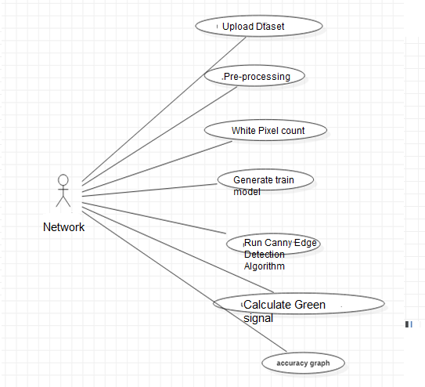

**Fig 2.1 Use case Diagram**

The use case diagram is used to represent all the functional use cases that are involved in the project.

The above diagram represents the main two **actors** in the project, they are

* + - User

### CLASS DIAGRAM

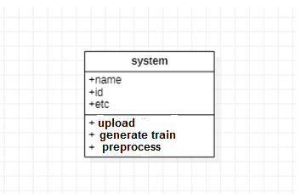

**Fig 3.2 class diagram**

The above mentioned class diagram represents the Chatbot system workflow model. This diagram has class models with class names as

* + - User
    - Home screen

### SEQUENCE DIAGRAM

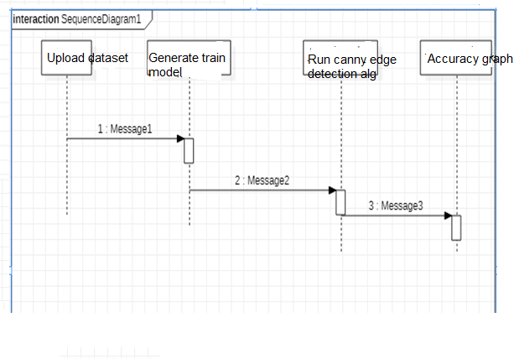

**Fig 3.5 sequence diagram**

The above diagram represents the sequence of flow of actions in the system.

### Activity DIAGRAM

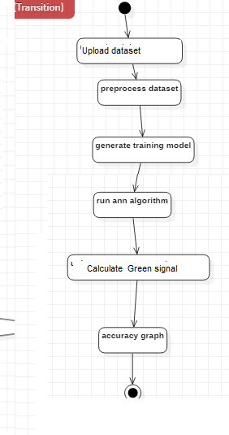

**STATE CHART DIAGRAM :-**



**DEPLOYEMENT DIAGRAM :-**

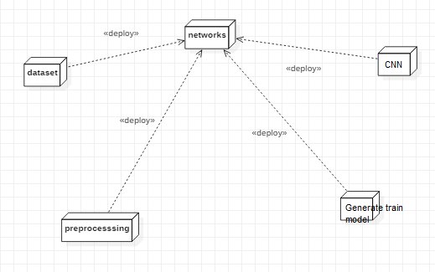

## DATA DESIGN

* + 1. **Databases SQLite**

|  |
| --- |
| **Name** |
| Density based smart traffic |

**Table 3.10.1 SQLite Database**

* + 1. **Tables**

|  |  |
| --- | --- |
| **Name** | **Description** |
| Users | Contains all the registered user details. |
| View upload data sets | All the registered service provider details. |
| Services | Contains all the types of services available. |

**Table 3.10.2 List of Database Tables**

## CONCLUSION

* In this paper, a smart traffic control system availing image processing as an instrument for measuring the density has been proposed. Besides explaining the limitations of current near obsolete traffic control system, the advantages of proposed traffic control system have been demonstrated. For this purpose, four sample images of different traffic scenario have been attained. Upon completion of edge detection, the similarity between sample images with the reference image has been calculated. Using this similarity, time allocation has been carried out for each individual image in accordance with the time allocation algorithm. In addition, similarity in percentage and time allocation have been illustrated for each of the four sample images using Python programming language. Besides presenting the schematics for the proposed smart traffic control system, all the necessary results have been verified by hardware implementation.

***CHAPTER - 4***

***SYSTEM LOWLEVEL DESIGN***

*This chapter gives an overview of all modules in the project.*

### CHAPTER 4

**SYSTEM LOWLEVEL DESIGN**

This chapter mainly provides the overview on modules of the application, objectives of the project and a detailed project overview.

* 1. **Modules of the Application:**

**Upload Image Module:**

In this module current traffic image will be uploaded to application and then convert colour image into Gray Scale image format to have pixels values as black and white colour.

**Pre-process module:**

In this module Gaussian Filter will be applied on uploaded image to convert image into smooth format. After applying filter Canny Edge Detection will be applied on image to get edges from the image. Each vehicle will have white colour pixels and non-vehicle will have black colour pixels.

**White Pixel Count Module:**

Using this module we will count white pixels from canny image to get complete traffic count

* 1. **OBJECTIVES OF THE PROJECT**

***CHAPTER - 5***

***IMPLEMENTATION***

*The chapter gives the details of the implementation.*

### CHAPTER 5 IMPLEMENTATION

This chapter mainly provides the sample code and implementation of the project.

* 1. **Sample Code**
     1. **XML Code**

*<?***xml version="1.0" encoding="utf-8"***?>*

<**LinearLayoutxmlns:android="**[**http://schemas.android.com/apk/res/android**](http://schemas.android.com/apk/res/android)**" android:layout_width="match_parent" android:layout_height="match_parent"**

**android:orientation="vertical"**>

<**android.support.v7.widget.LinearLayoutCompat android:layout_width="match_parent" android:layout_height="150dp" android:background="@color/colorTextHint" android:gravity="center" android:orientation="vertical"**>

<**android.support.v7.widget.AppCompatTextView android:layout_width="wrap_content" android:layout_height="wrap_content" android:text="Bookings" android:textSize="20sp"** />

<**android.support.v7.widget.AppCompatTextView android:layout_width="wrap_content" android:layout_height="wrap_content" android:layout_marginTop="10dp" android:text="@string/text_hello"** />

<**android.support.v7.widget.AppCompatTextView android:id="@+id/textViewName" android:layout_width="wrap_content" android:layout_height="wrap_content"** />

</**android.support.v7.widget.LinearLayoutCompat**>

<**android.support.v7.widget.AppCompatTextView android:layout_width="wrap_content" android:layout_height="wrap_content" android:paddingBottom="5dp" android:paddingLeft="16dp" android:paddingTop="5dp" android:text="Bookings" android:textColor="@android:color/black"** />

<**ScrollView android:id="@+id/scrollview" android:layout_width="fill_parent" android:layout_height="fill_parent" android:layout_below="@+id/spinner1" android:layout_alignParentBottom="true" android:layout_alignParentLeft="true"** >

<**LinearLayout android:layout_width="match_parent" android:layout_height="562dp" android:layout_marginBottom="200dp" android:orientation="vertical"** >

<**ListView**

**android:id="@+id/listView1" android:layout_width="wrap_content" android:layout_height="600dp" android:layout_marginLeft="0dp"** >

</**ListView**>

</**LinearLayout**>

</**ScrollView**>

</**LinearLayout**>

* + 1. **Java Code**

**package** com.example.spaceimpactor.houser.activities;

**import** java.util.ArrayList; **import** android.os.Bundle; **import** android.app.Activity; **import** android.content.Context; **import** android.content.Intent; **import** android.database.Cursor;

**import** android.database.sqlite.SQLiteDatabase;

**import** android.view.View;

**import** android.view.View.OnClickListener; **import** android.widget.AdapterView; **import** android.widget.ArrayAdapter; **import** android.widget.Button;

**import** android.widget.EditText; **import** android.widget.ImageView; **import** android.widget.ListView; **import** android.widget.Spinner; **import** android.widget.TextView;

**import** android.widget.AdapterView.OnItemClickListener;

**import** android.widget.Toast;

**import** com.example.spaceimpactor.houser.R;

**public class** Bookings **extends** Activity{ Spinner **sp**;

ImageView**out**; TextView**aaa**; SQLiteDatabase**db**; ListView**l**; EditText**t1**;

ArrayList<String>**list1**; ArrayAdapter**adapter**;

Button **sub**;

String **lmb**,**lser**,**lem**;

@Override

**protected void** onCreate(Bundle savedInstanceState) { **super**.onCreate(savedInstanceState); setContentView(R.layout.***activity_bookings***);

**final** GlobalClassglobalvariabel=(GlobalClass)getApplicationContext(); **aaa**=(TextView)findViewById(R.id.***textViewName***); **aaa**.setText(globalvariabel.GetUsername().toString());

**db**=openOrCreateDatabase(**"ServiceProvider"**, Context.***MODE_PRIVATE***, **null**); **l** = (ListView) findViewById(R.id.***listView1***);

**final** ArrayList<String> list = **new** ArrayList<String>();

**list1** = **new** ArrayList<String>();

Cursor res = **db**.rawQuery(**"SELECT * FROM book where uid='"** + **aaa**.getText() + **"'"**, **null**); **if** (res.getCount() != 0) {

**while** (res.moveToNext()) {

list.add(**"Name: "** + res.getString(1) + **"\nMobile No: "** + res.getString(2) + **"\n"** + **"Service Type: "** + res.getString(3) + **"\n"** + **"Email: "** + res.getString(4)+ **"\n"** + **"Booking Date: "** + res.getString(5));

**list1**.add(res.getString(1));

}

}

**adapter** = **new** ArrayAdapter<String>(**this**, android.R.layout.***simple_list_item_1***, list);

**l**.setAdapter(**adapter**);

}

}

* + 1. **Java Code**

**package** com.example.spaceimpactor.houser.fragment;

**import** android.content.Context;

**import** android.content.Intent;

**import** android.database.sqlite.SQLiteDatabase;

**import** android.os.Bundle;

**import** android.support.annotation.NonNull; **import** android.support.v4.app.Fragment; **import** android.text.TextUtils;

**import** android.util.Log;

**import** android.view.LayoutInflater;

**import** android.view.View;

**import** android.view.ViewGroup;

**import** android.support.annotation.Nullable;

**import** android.support.design.widget.Snackbar;

**import** android.support.design.widget.TextInputEditText; **import** android.support.design.widget.TextInputLayout; **import** android.support.v4.widget.NestedScrollView; **import** android.support.v7.app.AppCompatActivity; **import** android.support.v7.widget.AppCompatButton; **import** android.support.v7.widget.AppCompatTextView; **import** android.widget.Button;

**import** android.widget.EditText; **import** android.widget.ProgressBar; **import** android.widget.TextView; **import** android.widget.Toast;

**import** com.google.firebase.auth.FirebaseAuth; **import** com.google.firebase.auth.FirebaseUser; **import** com.google.firebase.database.DataSnapshot; **import** com.google.firebase.database.DatabaseError;

**import** com.google.firebase.database.DatabaseReference; **import** com.google.firebase.database.FirebaseDatabase; **import** com.google.firebase.database.ValueEventListener;

**public class** ProfileFragment**extends** Fragment **implements** View.OnClickListener {

**private** NestedScrollView**nestedScrollView**;

**private** TextInputLayout**textInputLayoutName**; **private** TextInputLayout**textInputLayoutPhone**; **private** TextInputLayout**textInputLayoutEmail**; **private** TextInputLayout**textInputLayoutPassword**;

**private** TextInputLayout**textInputLayoutConfirmPassword**;

**private** TextInputEditText**textInputEditTextName**; **private** TextInputEditText**textInputEditTextPhone**; **private** TextInputEditText**textInputEditTextEmail**; **private** TextInputEditText**textInputEditTextPassword**;

**private** TextInputEditText**textInputEditTextConfirmPassword**;

**private** AppCompatButton**appCompatButtonRegister**;

**private** InputValidation**inputValidation**; **private** DatabaseHelper**databaseHelper**; **private** User **user**;

EditText**id**,**ps**,**em**,**mb**; Button **sub**;

SQLiteDatabase**db**; TextView**aaa**;

**private static final** String ***TAG*** = MainActivity.**class**.getSimpleName();

**private** TextView**txtDetails**;

**private** EditText**inputName**, **inputEmail**; **private** Button **btnSave**;

**private** DatabaseReference**mFirebaseDatabase**;

**private** FirebaseDatabase**mFirebaseInstance**;

**private** String **userId**;

**private** Button **btnChangeEmail**, **btnChangePassword**, **btnSendResetEmail**, **btnRemoveUser**, **changeEmail**, **changePassword**, **sendEmail**, **remove**, **signOut**;

**private** EditText**oldEmail**, **newEmail**, **password**, **newPassword**; **private** ProgressBar**progressBar**;

**private** FirebaseAuth.AuthStateListener**authListener**;

**private** FirebaseAuth**auth**;

@Override

**public** View onCreateView(LayoutInflaterinflater, ViewGroup container, Bundle savedInstanceState) {

*// Inflate the layout for this fragment*

View myView = inflater.inflate(R.layout.***fragment_profile***, container, **false**);

*// appCompatButtonRegister = (AppCompatButton) myView.findViewById(R.id.appCompatButtonRegister);*

*// appCompatButtonRegister.setOnClickListener(this);*

**return** myView;

}

**private void** createUser(String name, String email) {

*//* ***TODO***

*// In real apps this userId should be fetched*

*// by implementing firebase auth*

**if** (TextUtils.*isEmpty*(**userId**)) {

**userId**= **mFirebaseDatabase**.push().getKey();

}

User user = **new** User();

**mFirebaseDatabase**.child(**userId**).setValue(user); addUserChangeListener();

}

*/\*\**

* *User data change listener*

*\*/*

**private void** addUserChangeListener() {

*// User data change listener* **mFirebaseDatabase**.child(**userId**).addValueEventListener(**new** ValueEventListener() { @Override

**public void** onDataChange(DataSnapshotdataSnapshot) { User user = dataSnapshot.getValue(User.**class**);

*// Check for null*

**if** (user == **null**) {

Log.*e*(***TAG***, **"User data is null!"**); **return**;

}

**inputEmail**.setText(**""**); **inputName**.setText(**""**);

}

@Override

**public void** onCancelled(DatabaseError error) {

*// Failed to read value*

Log.*e*(***TAG***, **"Failed to read user"**, error.toException());

}

});

}

**private void** updateUser(String name, String email) {

*// updating the user via child nodes*

**if** (!TextUtils.*isEmpty*(name))

**mFirebaseDatabase**.child(**userId**).child(**"name"**).setValue(name);

**if** (!TextUtils.*isEmpty*(email))

**mFirebaseDatabase**.child(**userId**).child(**"email"**).setValue(email);

}

*//sign out method* **public void** signOut() { **auth**.signOut();

}

@Override

**public void** onResume() { **super**.onResume(); **progressBar**.setVisibility(View.***GONE***);

}

@Override

**public void** onStart() {

**super**.onStart(); **auth**.addAuthStateListener(**authListener**);

}

@Override

**public void** onStop() {

**super**.onStop();

**if** (**authListener**!= **null**) {

**auth**.removeAuthStateListener(**authListener**);

}

}

**public void** onViewCreated(@NonNullView view, @NullableBundle savedInstanceState) {

**super**.onViewCreated(view, savedInstanceState);

*// initViews();*

*// initObjects();*

**auth**= FirebaseAuth.*getInstance*();

*//get current user*

**final** FirebaseUser user = FirebaseAuth.*getInstance*().getCurrentUser();

**authListener**= **new** FirebaseAuth.AuthStateListener() { @Override

**public void** onAuthStateChanged(@NonNullFirebaseAuthfirebaseAuth) { FirebaseUser user = firebaseAuth.getCurrentUser();

**if** (user == **null**) {

*// user auth state is changed - user is null*

*// launch login activity*

startActivity(**new** Intent(getActivity(), LoginActivity.**class**));

}

}

};

*// btnChangeEmail = (Button) findViewById(R.id.change_email_button);*

*//btnChangePassword = (Button) findViewById(R.id.change_password_button);* **btnSendResetEmail**= (Button) getView().findViewById(R.id.***sending_pass_reset_button***); **btnRemoveUser**= (Button) getView().findViewById(R.id.***remove_user_button***);

*// changeEmail = (Button) getView().findViewById(R.id.changeEmail);*

*// changePassword = (Button) getView().findViewById(R.id.changePass);*

**sendEmail**= (Button) getView().findViewById(R.id.***send***); **remove** = (Button) getView().findViewById(R.id.***remove***); **signOut**= (Button) getView().findViewById(R.id.***sign_out***);

**oldEmail**= (EditText) getView().findViewById(R.id.***old_email***); **newEmail**= (EditText) getView().findViewById(R.id.***new_email***); **password** = (EditText) getView().findViewById(R.id.***password***); **newPassword**= (EditText) getView().findViewById(R.id.***newPassword***);

**oldEmail**.setVisibility(View.***GONE***); **newEmail**.setVisibility(View.***GONE***); **password**.setVisibility(View.***GONE***); **newPassword**.setVisibility(View.***GONE***);

*// changeEmail.setVisibility(View.GONE);*

*// changePassword.setVisibility(View.GONE);* **sendEmail**.setVisibility(View.***GONE***); **remove**.setVisibility(View.***GONE***);

**progressBar**= (ProgressBar) getView().findViewById(R.id.***progressBar***);

**if** (**progressBar**!= **null**) {

**progressBar**.setVisibility(View.***GONE***);

}

**btnSendResetEmail**.setOnClickListener(**new** View.OnClickListener() { @Override

**public void** onClick(View v) { **oldEmail**.setVisibility(View.***VISIBLE***); **newEmail**.setVisibility(View.***GONE***); **password**.setVisibility(View.***GONE***); **newPassword**.setVisibility(View.***GONE***);

*// changeEmail.setVisibility(View.GONE);*

*// changePassword.setVisibility(View.GONE);* **sendEmail**.setVisibility(View.***VISIBLE***); **remove**.setVisibility(View.***GONE***);

}

});

**sendEmail**.setOnClickListener(**new** View.OnClickListener() { @Override

**public void** onClick(View v) {

**progressBar**.setVisibility(View.***VISIBLE***);

**if** (!**oldEmail**.getText().toString().trim().equals(**""**)) {

**auth**.sendPasswordResetEmail(**oldEmail**.getText().toString().trim())

.addOnCompleteListener(**new** OnCompleteListener<Void>() {

@Override

**public void** onComplete(@NonNullTask<Void> task) {

**if** (task.isSuccessful()) {

Toast.*makeText*(getActivity(), **"Reset password email is sent!"**, Toast.***LENGTH_SHORT***).show();

**progressBar**.setVisibility(View.***GONE***);

} **else** {

Toast.*makeText*(getActivity(), **"Failed to send reset email!"**, Toast.***LENGTH_SHORT***).show();

**progressBar**.setVisibility(View.***GONE***);

}

}

});

} **else** {

**oldEmail**.setError(**"Enter email"**); **progressBar**.setVisibility(View.***GONE***);

}

}

});

**btnRemoveUser**.setOnClickListener(**new** View.OnClickListener() { @Override

**public void** onClick(View v) {

**progressBar**.setVisibility(View.***VISIBLE***);

**if** (user != **null**) { user.delete()

@Override

.addOnCompleteListener(**new** OnCompleteListener<Void>() {

**public void** onComplete(@NonNullTask<Void> task) {

**if** (task.isSuccessful()) {

Toast.*makeText*(getActivity(), **"Your profile is deleted:( Create a account now!"**, Toast.***LENGTH_SHORT***).show(); startActivity(**new** Intent(getActivity(), RegisterActivity.**class**));

*// finish();*

**progressBar**.setVisibility(View.***GONE***);

} **else** {

Toast.*makeText*(getActivity(), **"Failed to delete your account!"**, Toast.***LENGTH_SHORT***).show();

**progressBar**.setVisibility(View.***GONE***);

}

}

});

}

}

});

**signOut**.setOnClickListener(**new** View.OnClickListener() { @Override

**public void** onClick(View v) { signOut();

}

});

*//txtDetails = (TextView) findViewById(R.id.txt_user);* **inputName**= (EditText) getView().findViewById(R.id.***name***); **inputEmail**= (EditText) getView().findViewById(R.id.***email***); **btnSave**= (Button) getView().findViewById(R.id.***btn_save***);

**mFirebaseInstance**= FirebaseDatabase.*getInstance*();

*// get reference to 'users' node*

**mFirebaseDatabase**= **mFirebaseInstance**.getReference(**"users"**);

*// store app title to 'app_title' node*

**mFirebaseInstance**.getReference(**"app_title"**).setValue(**"Houser"**);

*// app_title change listener* **mFirebaseInstance**.getReference(**"app_title"**).addValueEventListener(**new** ValueEventListener() { @Override

**public void** onDataChange(DataSnapshotdataSnapshot) { Log.*e*(***TAG***, **"App title updated"**);

String appTitle = dataSnapshot.getValue(String.**class**);

*// update toolbar title*

*//getSupportActionBar().setTitle(appTitle);*

}

@Override

**public void** onCancelled(DatabaseError error) {

*// Failed to read value*

Log.*e*(***TAG***, **"Failed to read app title value."**, error.toException());

}

});

*// Save / update the user* **btnSave**.setOnClickListener(**new** View.OnClickListener() { @Override

**public void** onClick(View view) {

String name = **inputName**.getText().toString(); String email = **inputEmail**.getText().toString();

*// Check for already existed userId* **if** (TextUtils.*isEmpty*(**userId**)) { createUser(name, email);

} **else** {

updateUser(name, email);

}

}

});

}

@Override

**public void** onClick(View v) { postDataToSQLite();

}

**private void** initViews() {

**nestedScrollView**= (NestedScrollView) getView().findViewById(R.id.***nestedScrollView***);

**textInputLayoutName**= (TextInputLayout) getView().findViewById(R.id.***textInputLayoutName***); **textInputLayoutPhone**= (TextInputLayout) getView().findViewById(R.id.***textInputLayoutPhone***); **textInputLayoutEmail**= (TextInputLayout) getView().findViewById(R.id.***textInputLayoutEmail***); **textInputLayoutPassword**= (TextInputLayout) getView().findViewById(R.id.***textInputLayoutPassword***); **textInputLayoutConfirmPassword**= (TextInputLayout) getView().findViewById(R.id.***textInputLayoutConfirmPassword***);

**textInputEditTextName**= (TextInputEditText) getView().findViewById(R.id.***textInputEditTextName***); **textInputEditTextPhone**= (TextInputEditText) getView().findViewById(R.id.***textInputEditTextPhone***); **textInputEditTextEmail**= (TextInputEditText) getView().findViewById(R.id.***textInputEditTextEmail***); **textInputEditTextPassword**= (TextInputEditText) getView().findViewById(R.id.***textInputEditTextPassword***); **textInputEditTextConfirmPassword**= (TextInputEditText) getView().findViewById(R.id.***textInputEditTextConfirmPassword***);

}

**private void** initObjects() {

**inputValidation**= **new** InputValidation(getActivity()); **databaseHelper**= **new** DatabaseHelper(getActivity()); **user** = **new** User();

}

**private void** postDataToSQLite() {

**if** (!**inputValidation**.isInputEditTextFilled(**textInputEditTextName**, **textInputLayoutName**, getString(R.string.***error_message_name***))) {

**return**;

}

**if** (!**inputValidation**.isInputEditTextFilled(**textInputEditTextPhone**, **textInputLayoutPhone**, **"Enter Phone Number"**)) {

**return**;

}

**if** (!**inputValidation**.isInputEditTextFilled(**textInputEditTextEmail**, **textInputLayoutEmail**, getString(R.string.***error_message_email***))) {

**return**;

}

**if** (!**inputValidation**.isInputEditTextFilled(**textInputEditTextEmail**, **textInputLayoutEmail**, getString(R.string.***error_message_email***))) {

**return**;

}

**if** (!**inputValidation**.isInputEditTextEmail(**textInputEditTextEmail**, **textInputLayoutEmail**, getString(R.string.***error_message_email***))) {

**return**;

}

**if** (!**inputValidation**.isInputEditTextPhone(**textInputEditTextPhone**, **textInputLayoutPhone**, getString(R.string.***error_message_phone***))) {

**return**;

}

**if** (!**inputValidation**.isInputEditTextFilled(**textInputEditTextPassword**, **textInputLayoutPassword**,

getString(R.string.***error_message_password***))) {

**return**;

}

**if** (!**inputValidation**.isInputEditTextMatches(**textInputEditTextPassword**, **textInputEditTextConfirmPassword**, **textInputLayoutConfirmPassword**, getString(R.string.***error_password_match***))) {

**return**;

}

**if** (!**databaseHelper**.checkUser(**textInputEditTextEmail**.getText().toString().trim())) {

**user**.setName(**textInputEditTextName**.getText().toString().trim()); **user**.setPhone(**textInputEditTextPhone**.getText().toString().trim()); **user**.setEmail(**textInputEditTextEmail**.getText().toString().trim()); **user**.setPassword(**textInputEditTextPassword**.getText().toString().trim());

**databaseHelper**.updateUser(**user**); emptyInputEditText();

}

}

**private void** emptyInputEditText()

{

**textInputEditTextName**.setText(**null**); **textInputEditTextPhone**.setText(**null**); **textInputEditTextEmail**.setText(**null**); **textInputEditTextPassword**.setText(**null**); **textInputEditTextConfirmPassword**.setText(**null**);

}

}

**5.1.3 XML Code**

*<?***xml version="1.0" encoding="utf-8"***?>*

<**android.support.v4.widget.NestedScrollView xmlns:android="**[**http://schemas.android.com/apk/res/android**](http://schemas.android.com/apk/res/android)**" xmlns:tools="**[**http://schemas.android.com/tools**](http://schemas.android.com/tools)**"**

**xmlns:app="**[**http://schemas.android.com/apk/res-auto**](http://schemas.android.com/apk/res-auto)**" android:id="@+id/nestedScrollView" android:layout_width="match_parent" android:layout_height="match_parent" android:paddingBottom="20dp" android:paddingLeft="20dp" android:paddingRight="20dp" android:paddingTop="20dp"**>

<**LinearLayout android:layout_width="match_parent" android:layout_height="wrap_content" android:orientation="vertical"**

**android:paddingBottom="@dimen/activity_vertical_margin" android:paddingLeft="@dimen/activity_horizontal_margin" android:paddingRight="@dimen/activity_horizontal_margin" android:paddingTop="0dp" app:layout_behavior="@string/appbar_scrolling_view_behavior"**>

<**TextView android:layout_width="match_parent" android:layout_height="match_parent"**

**android:text="Update your Profile" android:textColor="@android:color/black" android:textStyle="bold" android:textSize="30sp" android:layout_marginBottom="70dp" android:gravity="center"**/>

<**EditText android:id="@+id/old_email" android:layout_width="match_parent" android:layout_height="wrap_content" android:hint="Confirm Email"**

**android:inputType="textEmailAddress" android:maxLines="1" android:singleLine="true"** />

<**EditText android:id="@+id/new_email" android:layout_width="match_parent" android:layout_height="wrap_content" android:hint="New Email" android:inputType="textEmailAddress" android:maxLines="1" android:singleLine="true"** />

<**EditText android:id="@+id/password" android:layout_width="match_parent" android:layout_height="wrap_content" android:focusableInTouchMode="true" android:hint="@string/hint_password" android:imeActionId="@+id/login"**

**android:imeOptions="actionUnspecified" android:inputType="textPassword" android:maxLines="1" android:singleLine="true" tools:ignore="InvalidImeActionId"** />

<**EditText android:id="@+id/newPassword" android:layout_width="match_parent" android:layout_height="wrap_content" android:focusableInTouchMode="true" android:hint="New Password" android:imeActionId="@+id/login" android:imeOptions="actionUnspecified" android:inputType="textPassword" android:maxLines="1" android:singleLine="true" tools:ignore="InvalidImeActionId"** />

<**Button android:id="@+id/send"**

**style="?android:textAppearanceSmall" android:layout_width="wrap_content" android:layout_height="wrap_content" android:layout_marginTop="16dp" android:background="@android:color/black" android:text="Send" android:textColor="@android:color/white" android:textStyle="bold" android:layout_gravity="end"**/>

<**ProgressBar android:id="@+id/progressBar" android:layout_width="30dp" android:layout_height="30dp" android:visibility="gone"** />

<**Button android:id="@+id/remove"**

**style="?android:textAppearanceSmall" android:layout_width="wrap_content" android:layout_height="wrap_content" android:layout_marginTop="16dp" android:background="@color/colorPrimaryDark" android:text="Remove" android:textColor="@android:color/white" android:textStyle="bold"** />

<**android.support.design.widget.TextInputLayout android:layout_width="match_parent" android:layout_height="wrap_content"**>

<**EditText android:id="@+id/name"**

**android:layout_width="match_parent" android:layout_height="wrap_content" android:hint="Name" android:inputType="textCapWords" android:maxLines="1"** />

</**android.support.design.widget.TextInputLayout**>

<**android.support.design.widget.TextInputLayout android:layout_width="match_parent" android:layout_height="wrap_content"**>

<**EditText android:id="@+id/email"**

**android:layout_width="match_parent" android:layout_height="wrap_content" android:hint="Email" android:inputType="textEmailAddress" android:maxLines="1"** />

</**android.support.design.widget.TextInputLayout**>

## Screen Captures

* + 1. **User Login Screen:**

To implement this project we are using 4 input images given in paper and on reference image. Below are the images screen shots saved inside images folder

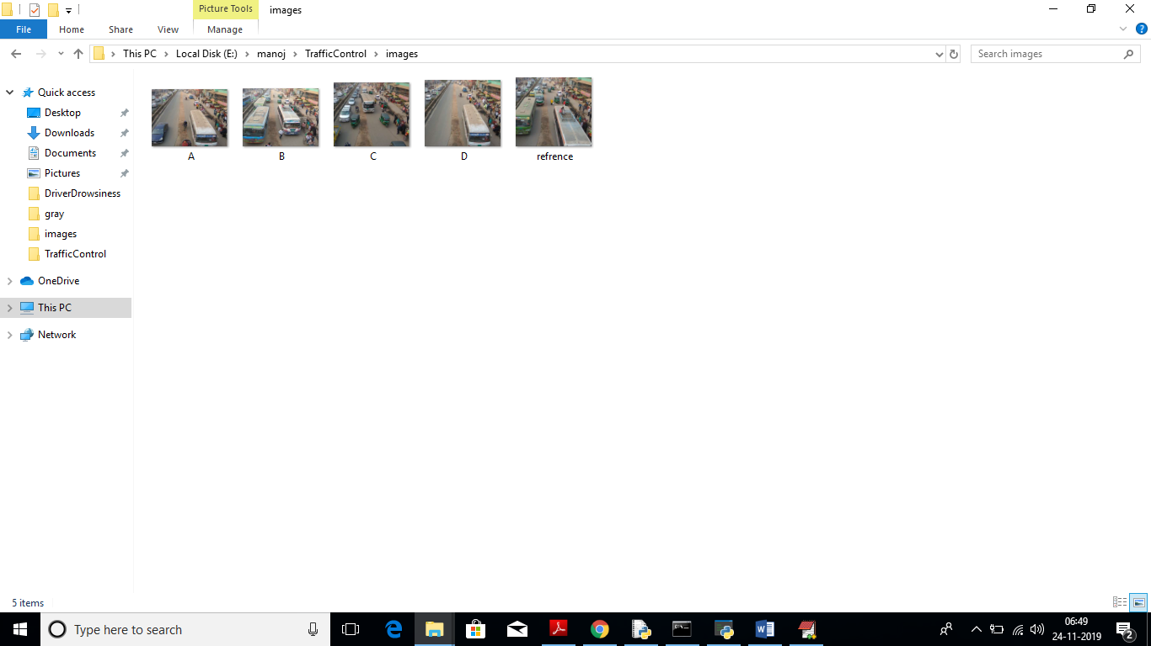

We can upload above 4 images to application to calculate traffic signal time.

Screen shots

To run this project double click on ‘run.bat’ file to get below screen

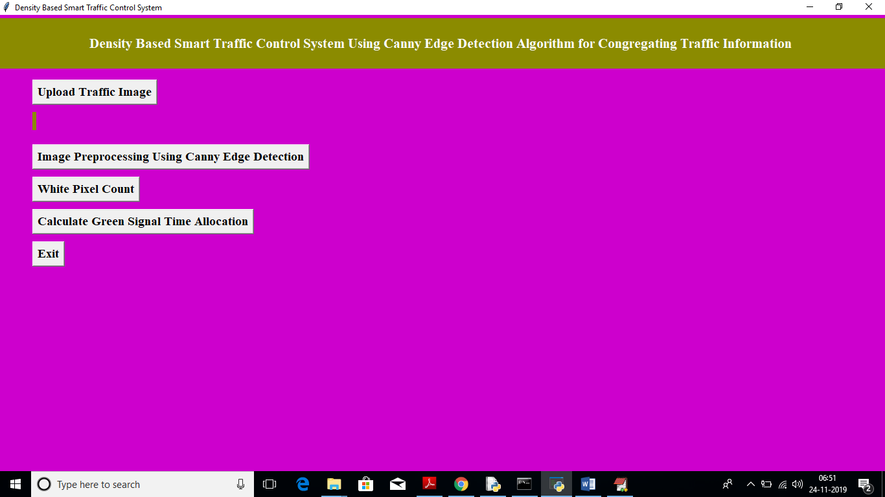

In above screen click on ‘Upload Traffic Image’ button to upload image.

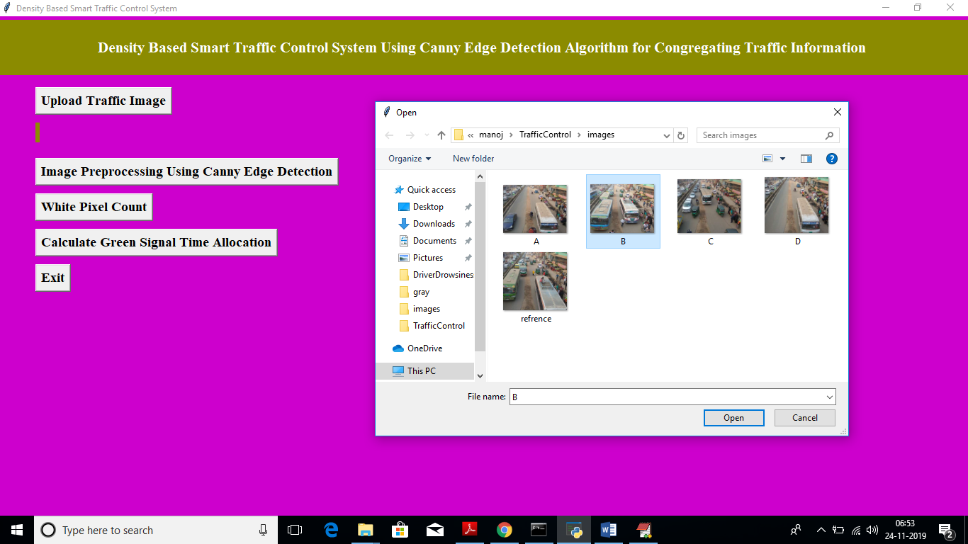

In above screen I am uploading image B and now click on ‘Open’ button to load image

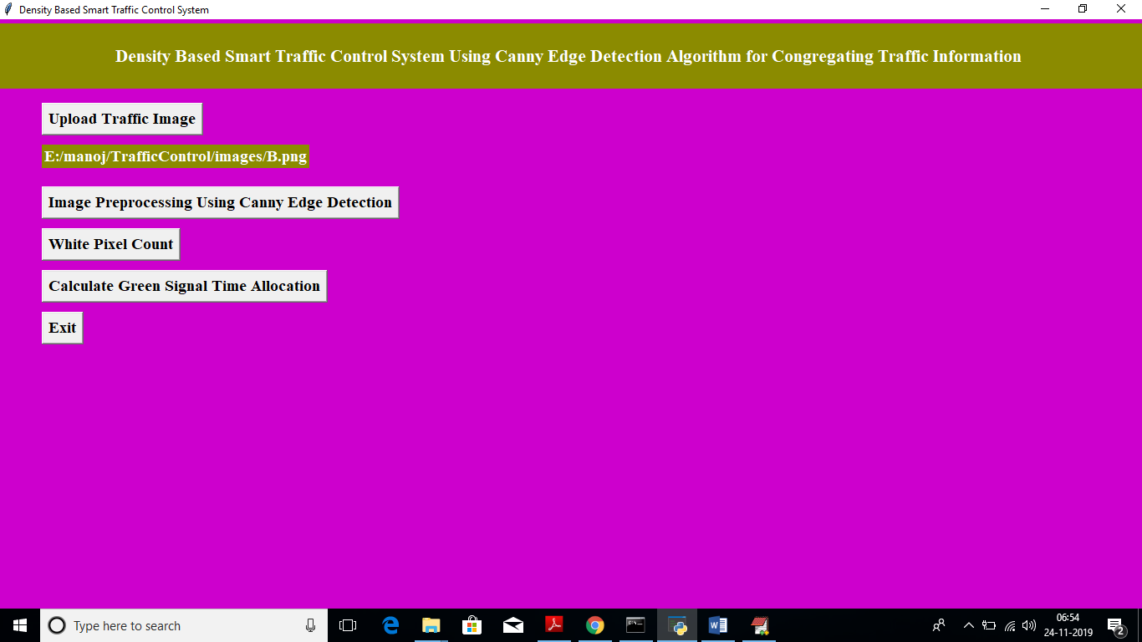

In above screen we got message as input image loaded. Now click on ‘Image Pre-processing Using Canny Edge Detection’ button to apply Gaussian filter and to get canny edges, after clicking button wait for few seconds till you get below screen with edges

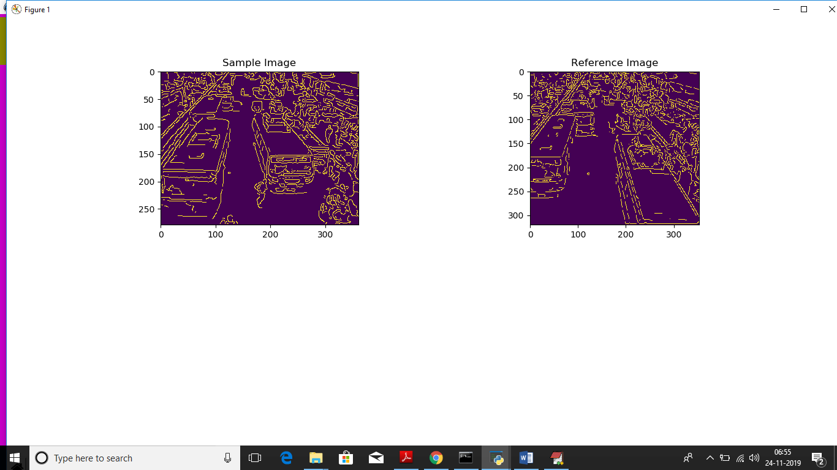

In above screen left side image is the uploaded image and right side is the ‘Reference Image’, Now close this above screen and click on ‘White Pixel count’ button to get white pixels from both images

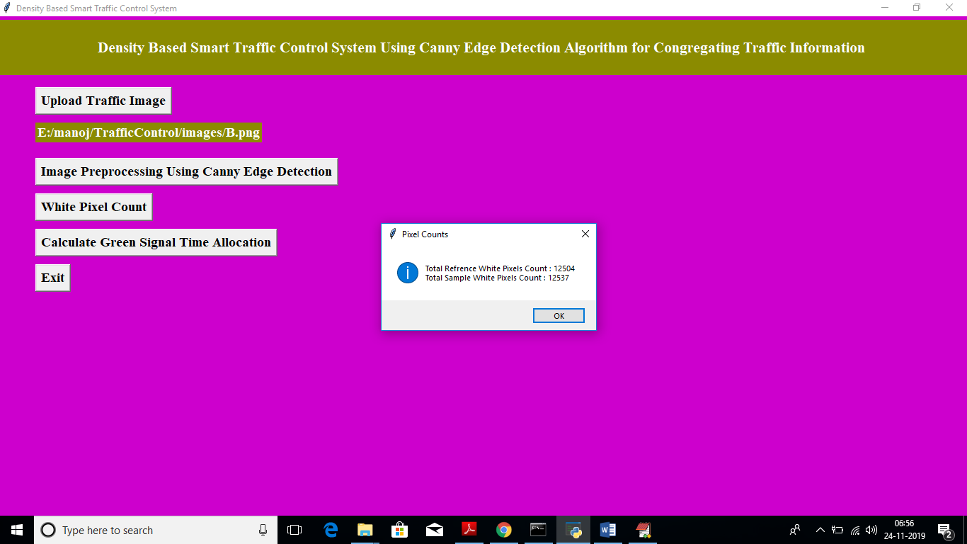

In above screen dialog box we can see total white pixels found in both sample and reference image. Now click on ‘Calculate Green Signal Time Allocation’ button to get signal time

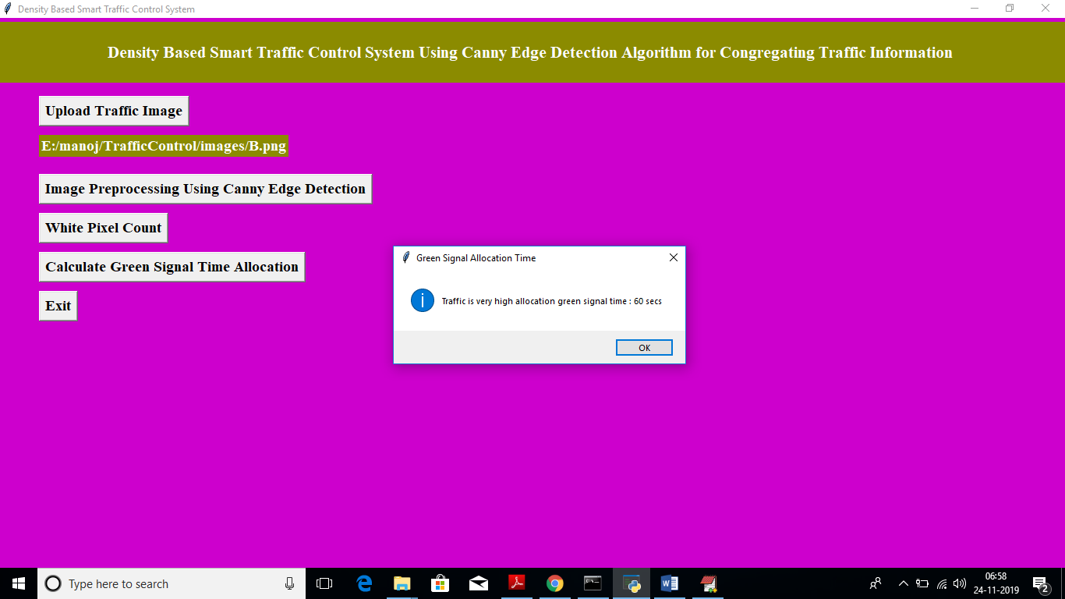

For that uploaded image we got message as it contains high traffic and signal time must be 60 seconds. Similarly you can upload any image and get output. Below is the output for image A

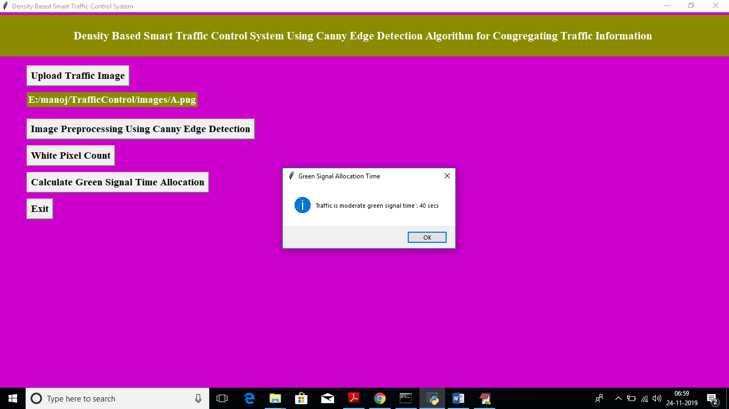

Above time for image A

***CHAPTER - 6***

***TESTING***

*The chapter shows the various test cases.*

# CHAPTER 6

## Software Testing

Software testing is the process of validating and verifying that a software applicationmeets the technical requirements which are involved in its design and development. It is alsoused to uncover any defects/bugs that exist in the application. It assures the quality of thesoftware. There are many types of testing software viz., manual testing, unit testing, black box testing, performance testing, stress testing, regression testing, white box testing etc. Among theseperformance testing and load testing are the most important one for an android application and nextsections deal with some of these types.

## Black box Testing

Black box testing treats the software as a "black box"—without any knowledge of internal implementation. Black box testing methods include equivalence partitioning, boundary value analysis, all-pairs testing, fuzz testing, model-based testing, traceability matrix, exploratory testing,and specification-based testing.

## White box Testing

White box testing is when the tester has access to the internal data structures and algorithms including the code that implement these.

## Performance Testing

Performance testing is executed to determine how fast a system or sub-system performsunder a particular workload. It can also serve to validate and verify other quality attributes of thesystem such as scalability, reliability and resource usage.

## Load Testing

Load testing is primarily concerned with testing that can continue to operate underspecific load, whether that is large quantities of data or a large number of users.

## Manual Testing

Manual Testing is the process of manually testing software for defects. Functionality of this application is manually tested to ensure the correctness. Few examples of test case for Manual Testing are discussed later in this chapter.

|  |  |
| --- | --- |
| **Test Case 1** | |
| Test Case Name | Empty login fields testing |
| Description | In the login screen if the username and password fields are empty |
| Output | Login fails showing an alert box asking to enter username and  password. |

**Table 6:1 Test Case for Empty Login Fields**

**Figure 6-1 Test Case for Empty Login Fields**

|  |  |
| --- | --- |
| **Test Case 2** | |
| Test Case Name | Wrong login fields testing |
| Description | A unique username and password are set by administrator. On entering wrong username or password gives. |
| Output | Login fails showing an alert box username or password  incorrect. |

**Table 6:2 Test Case for Wrong Login Fields**

**Figure 6-2 Test Case for Wrong Login Fields**

|  |  |
| --- | --- |
| **Test Case 3** | |
| Test Case Name | User Signup Fails. |
| Description | User signup need to provide all data. |
| Output | Signup Fails and an alert message appears asking to enter valid email and name. |

**Table 6:3 Test Case for Signup fail**

***CHAPTER - 7***

***RESULTS &CHALLENGES***

*The chapter describes the results and challenges faced in the project.*

# CHAPTER 7

**RESULTS AND CHALLENGES**

## Results

The current android application is developed using Xml, Java, SQL with Firebase connectivity. It can be used by every individual who are in a need of fulfilling their household services.

At the time of submission of my application was capable of doing the following:

* + Displaying thehome screen with different fragments.
  + Authentication of user by using login screen using Firebase.
  + Home screen to display based on user or service provider.
  + After successful login of user, they can choose the service and book a slot of their particular service provider from the displayed list.
  + Add, update, view, delete the user details.
  + After successful login of service provider, they can view all the bookings that are booked by the users and can attend them one by one.
  + Service provider can also set his preferences to not available, if he’s too busy or many users had already booked him.
  + Service provider has the ability to change their particular radius of location for servicing.
  + He can set up to 10 km radius.
  + Logout and end the session.

## Challenges

* + - Understanding the connections of SQLite Database is a tricky part and confusing when dealing with multiple tables within a database.
    - Making exact orientation API design levels was a difficult task as there are many types of devices like desktop, tablet, mobile with varying screen size and resolutions.
    - Implementing synchronization with Firebasewas a challenging task.
    - Learning different technologies and frameworks with little guidance.

***CHAPTER - 8***

***CONCLUSIONS & FUTURE WORK***

*The chapter gives brief conclusion about the project.*

# CHAPTER 8

# CONCLUSION

## Conclusion

* In this paper, a smart traffic control system availing image processing as an instrument for measuring the density has been proposed. Besides explaining the limitations of current near obsolete traffic control system, the advantages of proposed traffic control system have been demonstrated. For this purpose, four sample images of different traffic scenario have been attained. Upon completion of edge detection, the similarity between sample images with the reference image has been calculated. Using this similarity, time allocation has been carried out for each individual image in accordance with the time allocation algorithm. In addition, similarity in percentage and time allocation have been illustrated for each of the four sample images using Python programming language. Besides presenting the schematics for the proposed smart traffic control system, all the necessary results have been verified by hardware implementation.

## Scope for future work

## 

## the similarity between sample images with the reference image has been calculated. Using this similarity, time allocation has been carried out for each individual image in accordance with the time allocation algorithm. In addition, similarity in percentage and time allocation have been illustrated for each of the four sample images using Python programming language. Besides presenting the schematics for the proposed smart traffic control system, all the necessary results have been verified by hardware implementation.

## Limitations

# BIBLIOGRAPHY

Code snippets for any errors <http://stackoverflow.com/>

Android Development Guide htt[ps://www](http://www.udemy.com/android).[udemy.com/android](http://www.udemy.com/android)

Xml and Layout Guide htt[ps://www](http://www.androidhive.com/).[androidhive.com/](http://www.androidhive.com/)

Connecting to Firebase Docs https://firebase.google.com

Software Testing <http://en.wikipedia.org/wiki/Software_testing>

Manual Testing <http://en.wikipedia.org/wiki/Manual_testing>

Performance Testing <http://en.wikipedia.org/wiki/Software_performance_testing>